2ND PHASE SUBMISSION

Parts of game:

The program will consist of following parts

1. Main function
2. Menu function
3. Signup function
4. Login function
5. Game modes function
6. Easy mode function
7. Normal mode function
8. Hard mode function

Algorithm:

1). the game has **different phases**. Each phase has its own functionality.

2).Firstly, in the main function, the function called as “**menu**” will be called.

3). The menu function has different parts in it for example the menu functions asks a user if he wants to sign up for the game or he/she wants to login into their game and third option is to quit the game.

4). the user is treated with whatever he chooses.

5).After choosing an option, the user enters in that phase

6). for example if the user chooses **sign up**, then some information is gathered from the

7).which includes name, password, cnic number, gender.

8). after all that, sign up is done then to confirm the user, the user name and password are then again asked in the login function.

9).In the **login**, the user enters his/her name and password and if both of them matches, the user is allowed to move further.

10).The third option of the menu function is “**quit”** option. If the user chooses quit option then the user exits the game.

11).After all signing up and logging in, the user is asked that which **mode** he/she wants to play i.e. **easy**, **normal** or **hard**.

12).If the user is playing for the first time and user chooses to play normal or hard mode first, then user is asked to play easy mode first then normal and then hard otherwise he/she would not be able to play.

13).Then comes the **easy mode**. After choosing easy mode, the user enters into the game where there are aliens who are firing and a spaceship who is also firing.

14). Aliens have different colors in them and so does the spaceship. The spaceship moves and shoots .

15).In each mode, aliens have different health for example in easy mode they have lesser health as compared to normal and normal mode has lesser health as compared to hard mode

16).Whenever the bullet of spaceship strike the aliens, the health decrease and after certain hits, the aliens vanish and we get score.

17).Similarly, when all the aliens are finished, the game is over and a message **you win** is printed on the screen or if the spaceship faces enough damage then, spaceship is destroyed and a message **you lose** if displayed on the screen.

**18).In normal mode**, there are more number of aliens and their health is increased so, it becomes hard to kill those aliens similarly, our health is decreased so we can be killed rather easily.

19).Then lastly, the **hard mode**. Hard mode is similar to easy and normal mode but with mode aliens and more health for the aliens and lesser health for the spaceship which makes it difficult to kill the aliens but it becomes easy to kill us.

**20).All the record of the user is recorded** for example his/her name gender password etc. after the game is over the score is the stored in the user’s id and also the comparison of gender is done i.e. who, the male or female players, has played more and the result is also printed.

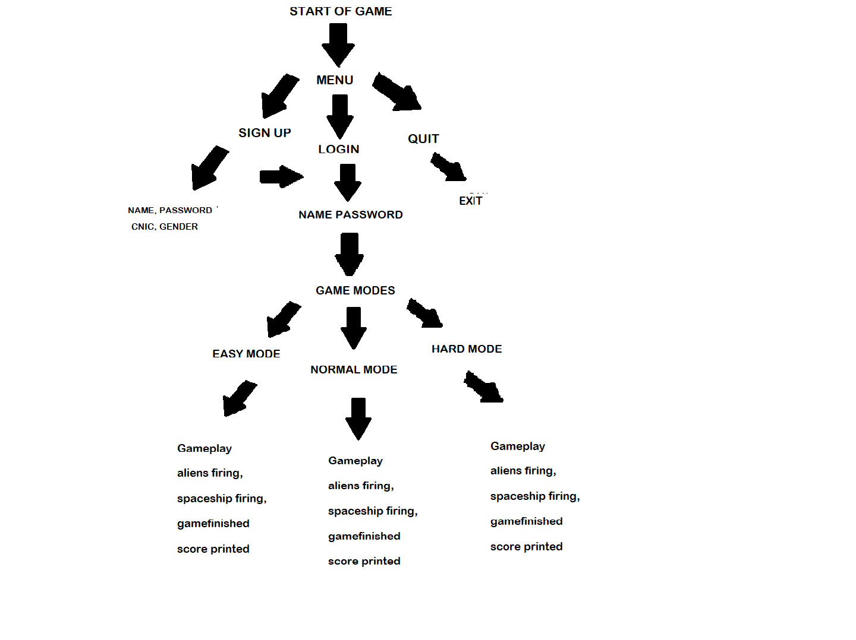

SIR’S RECOMMENDATION:

* To add age.